**LINUX**

**Introduction to OS :**

An Operating System (OS) is a software program that acts as an intermediary between the computer hardware and the user. Its primary goal is to make the computer system convenient to use and to utilize the hardware in an efficient manner**.**

Examples of Popular Operating Systems:

* Windows: A widely-used OS from Microsoft, primarily for personal computers.
* Linux: An open-source OS known for its flexibility and security.
* macOS: The operating system used on Apple’s Macintosh computers.
* Android and iOS: Operating systems used for mobile devices.

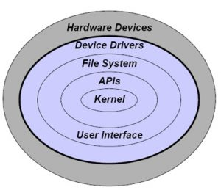

**Services of OS:**

Operating systems provide various services that make it easier for users and application programs to utilize the hardware efficiently. These services include:

1. **Program Execution:** The OS loads programs into memory, manages their execution, and terminates them when they are complete.

2. **Operations I/O**: Input/Output operations include reading from and writing to external devices such as disks, keyboards, and printers. The OS provides services to manage these operations.

3. **Fil System Managemente**: The OS handles the creation, deletion, reading, writing, and organization of files on storage devices.

4. **Communication**: Operating systems provide communication mechanisms between processes. Examples include message passing, shared memory, and sockets.

5. **Error Detection and Handling:** The OS monitors the system for potential errors in hardware, software, and takes corrective actions such as logging errors, terminating processes etc.

**Need of OS:**

OS as a platform for Application programs: The operating system provides a platform, on top of which, other programs, called application programs can run. It acts as an interface between the computer and the user. It is designed in such a manner that it operates, controls, and executes various applications on the computer.

* Managing Input-Output unit
* Multitasking
* A platform for other software applications
* Controls memory:
* Looks after system file

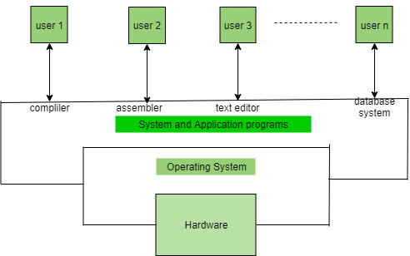

**What is LINUX:**

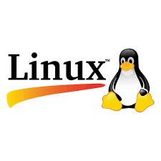

Linux is a free and open-source family of operating systems that is resilient and flexible. In 1991, an individual by the name as Linus Torvalds constructed it. The system’s source code is accessible to everyone for anyone to look at and change. People from all across the world are urged to work together and keep developing Linux due to its openness. Since the beginning, Linux has grown into a dependable and safe OS that is used in an array of gadgets, including PCs, cell phones, and huge supercomputers. It is well-known for being cost-effective, which implies that employing it doesn’t cost a lot, and efficient, which indicates it can complete a lot of jobs quickly.

**Need of LINUX:**

1. **Open-Source and Free**:

Linux is freely available for personal and commercial use. Users don’t need to pay licensing fees, making it a cost-effective solution for individuals etc.

2. **Security**: Linux is known for its strong security model. It is less vulnerable to viruses and malware compared to other operating systems like Windows.

3. **Stability and Reliability**: Linux is highly stable, which makes it ideal for servers, network device.

4. **Performance**: Linux is lightweight and performs well on older hardware, making it ideal for machines with limited resources.

5. **Community Support**: Linux has a large, active community of developers and users who provide free support through forums, mailing lists, and documentation.

And many more..

**Distribution of LINUX :**

* A Linux distribution is an OS made through a software collection that contains the Linux kernel and a package management system often.

A Linux distribution is composed of a Linux kernel, GNU libraries and tools, other software, a window system, documentation, a desktop environment, and a window manager.

* Optionally, Linux distributions add a few proprietary software that might not be available in the source code form, like binary blocks needed for a few device drivers.

**Linux Distributions List:**

1) Ubuntu

2) Linux Mint

3) Debian

4) Red Hat Enterprise / CentOS

5) Fedora

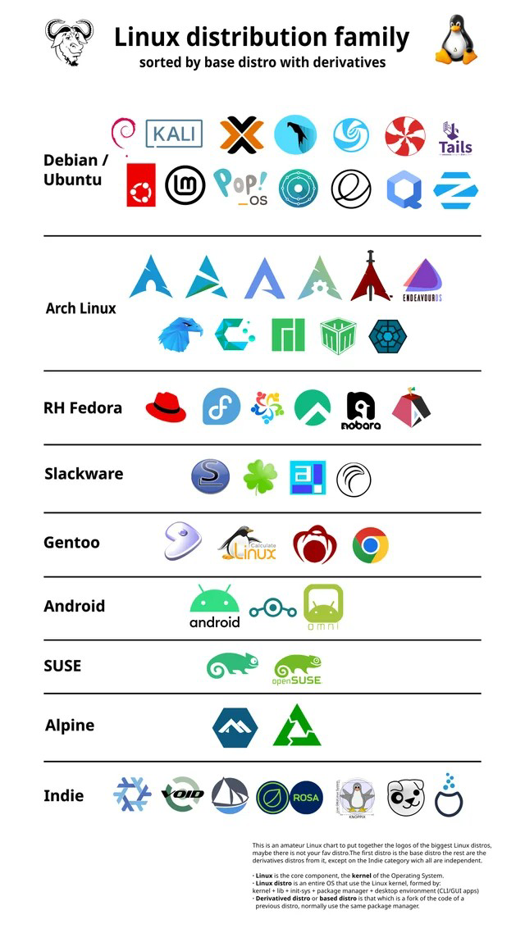

**Linux Services in brief:**

* Custom .NET application Development on Linux using Mono
* Linux Multi-Purpose business solution servers
* Onsite or remote linux system monitoring and administration
* Remote system / Server maintenance
* Low and high speed Co-Location services for startups and high bandwidth servers
* Upgrading the servers as needed to current patch levels to minimize security risks
* 24x7x365 system admin coverage – full-time, part-time, hourly basis
* Automated server monitoring and notification/paging system
* Administration of the basesystem Configuration and administration of network infrastructure.
* Messaging Solutions and Linux Antivirus Services
* Administration services